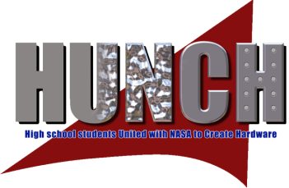

High School Students United with NASA to Create Hardware
(HUNCH)
Statement of Work
The mission of the HUNCH program is to empower and inspire students through a Project Based Learning program where students learn 21st century skills and have the opportunity to launch their careers through the participation in the design and fabrication of real world valued products for NASA.
It is no longer necessary for a Space Act Agreement to be put in place for Culinary Schools, but we do need to have the following information below:
School Information

- Name, address and phone number of school district Superintendent:

- Name, address and phone number of CATE Director:

- Name, address and phone number of school:

- Name, phone number and email of school principal:

- Name, phone number and email of teacher or teachers applying to be involved in the HUNCH Program

- The title of the course or courses proposed to be involved in HUNCH

- Approximate number of student participants and their grade levels

8. Number of high schools in your district?

9. Number of students (K-12) in your district?

10. Names of counties that are in your school district?

Facilities/Equipment
- Description of classroom facilities where the HUNCH activity will take place

Please email your Statement of Work to:
Allison.r.westover@nasa.gov

